**Assignment 05**

**KD1-Indrajeet-86641**

Q1. Write a query that will give you all orders for more than Rs. 1,000.

🡺 select * from sales where amt > 1000;

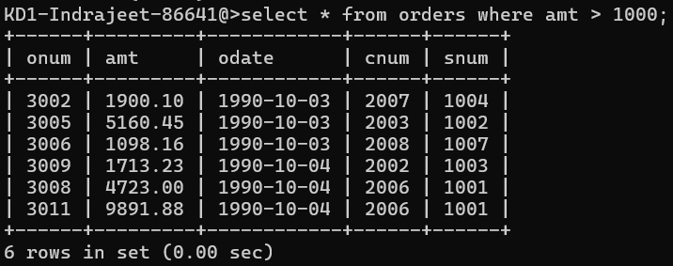

Q2. Write a query that will give you the names and cities of all salespeople in London with a commission above 0.10.

🡺 select sname, city from salespeople where comm > 0.10;

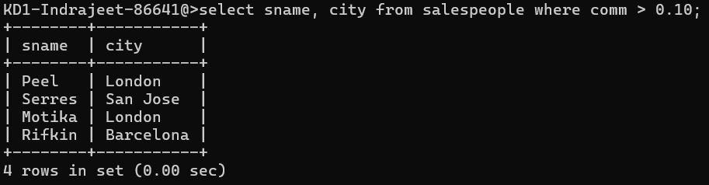

Q3. Write a query on the Customers table whose output will exclude all customers with a rating <= 100, unless they are located in Rome.

🡺 select * from customers where rating > 100 OR city = ‘rome’;

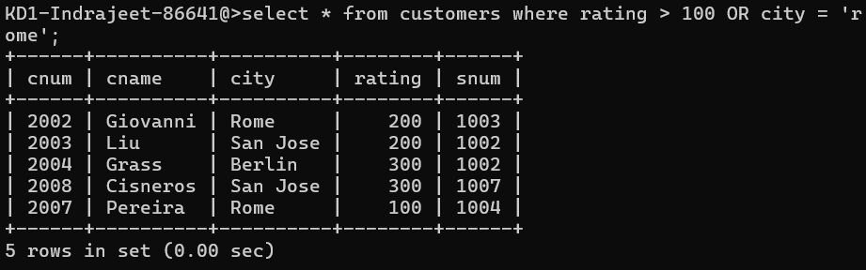

Q4. What will be the output from the following query? Select * from Orders where (amt < 1000 OR NOT (odate = ‘1990-10-03’ AND cnum > 2003));

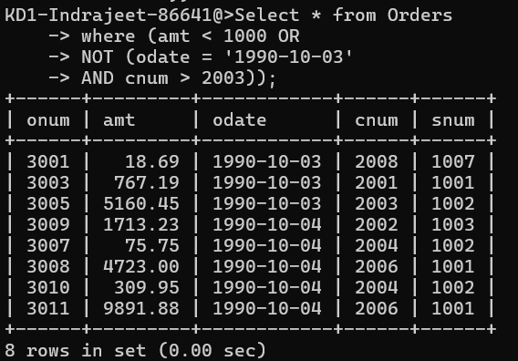

Q5. What will be the output of the following query? Select * from Orders where NOT ((odate = ‘1990-10-03’ OR snum >1006) AND amt >= 1500);

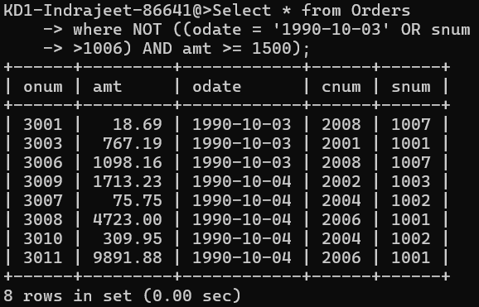

Q6. What is a simpler way to write this query? Select snum, sname, city, comm From Salespeople where (comm > .12 OR comm < .14);

